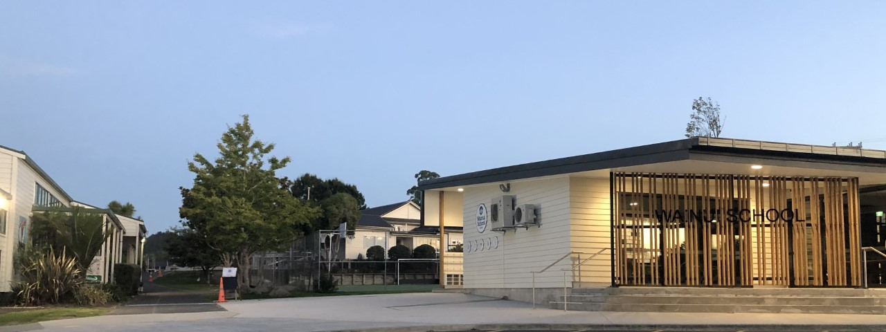
2025

WAINUI SPONSORSHIP



SPONSORSHIP DOCUMENT

About Sponsorship


Become a Sponsor of Wainui School
Many schools are underfunded and Wainui School is no exception. We need to continually raise money to maintain the excellent class and environmental standards we have set, to help Wainui School children reach their highest potential. We have five fundraising events each year.
A-thon Student Fundraiser
Family Whittaker’s Chocolate Fundraiser

Quiz Night Fundraiser
Agriculture Day & Country Fair
Christmas in the Country
Each fundraising event has one Principal Sponsor, who headlines the event in conjunction with the school. There are also Support Sponsors who sponsor individual stalls/prizes at each event. We also have Project Sponsorship opportunities which you can get involved with.

We hope there is a sponsorship opportunity in this document that is of interest to you, and look forward to discussing any event or project with you in the near future. With your help we can make all of our dreams for our school come true!


Sponsorship Opportunities
Event/Project | When | Description | Principal Sponsor: $ Amount | Support Sponsor: $ Amount
A-thon Student Fundraiser | Term 1 | In previous years we have had a Spell-a-thon, Math-a-thon;  Lap-a-thon and Bike-a-thon.  This year our students hosted a Bike-a-thon event on the school's bike track, and students were encouraged to get sponsors to pay them for every lap that they completed. | $1,500 minimum amount required to cover the cost of prizes, food and drink on the day. | $100 - $500
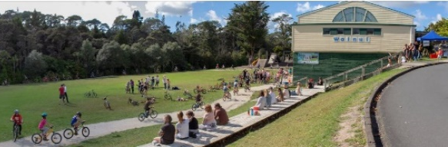 |  |  |  | $100 - $500
“Last year we raised $23,000 in our Bike-a-thon event, to put towards upgrading our Garden to Table programme, garden and buying more bikes.”
Quiz Night Fundraiser  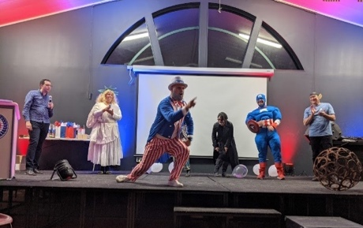 | Term 2 | Our Quiz Night is hosted on XXX 2025 in our school hall. It is a fun night with teams dressing up in theme (as there is a prize for the best-dressed table) and teams battle to see who has the greatest knowledge of all matters trivial.  General knowledge and trivial interest questions are asked by our trivia ‘celebrity’ hosts, and the winners are the team which, at the end of the night, have correctly answered the greatest number of | $1,500 minimum amount required to cover the cost of prizes, some raffles, nibbles for the table and some silent auction items.  Harcourts Cooper & Co – Auctioneer. | $100 - $1,000
Event/Project | When | Description | Principal Sponsor: $ Amount | Support Sponsor: $ Amount
Family Whittaker’s Chocolate/ or similar TBC  Fundraiser | Term 3 | This is a great way to support the school (especially if you love chocolate!!). Launch date is XXX 2025.  The chocolate is delivered in boxes to each family/eldest child to sell at least one box of Whittaker’s Chocolates.  There are some great prizes and incentives for the kids to get involved, and a major spot prize up for grabs! | $1,000 minimum amount required to cover the cost of prizes to help incentivise sales! | $100 - $1,000
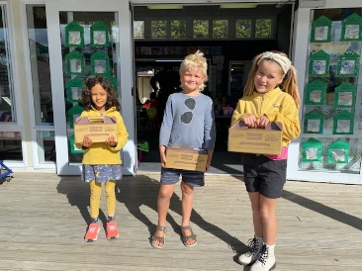 |  |  |  | $100 - $1,000
Agriculture Day and  Country Fair | Term 4 | Ag Day is on 24th October 2025, it has been held annually at Wainui School since the early 1950s. This event attracts parents, grandparents, aunts, uncles, friends, past pupils, other schools and neighbours.  This day has various activities, both indoor and outdoor. Children raise a pet calf, lamb, kid goat or chicken to present in various categories. Ribbons are distributed after judging. We have a country market fair where stallholders can sell their wares and we have Fair games for the children and adults alike! | $2,500 minimum amount required to cover the cost of food, entertainment, drinks and raffles.  Harcourts Cooper & Co – Coffee & Cone. | $100 - $1,000
 |  |  |  | $100 - $1,000
Christmas in the Country | Term 4 | Christmas in the Country is on 4th December 2025, it has become a wonderful Wainui School tradition.  We all meet at school in the early evening (normally in the last few weeks of school), to enjoy a picnic style dinner and entertainment with each school year group presenting a couple of Christmas songs. There is lots of singing and dancing in between! The teachers serve hot pork rolls and man the BBQ while the children entertain us with dancing and singing. | $1,500 minimum amount required to cover the cost of food and drinks to sell and raffle items. | $100 – 500
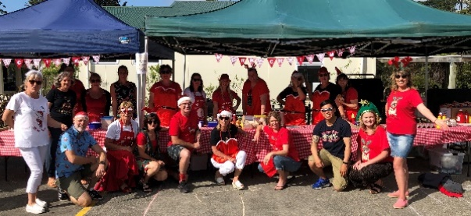 |  |  |  | $100 – 500

Event Sponsorship Benefits

The benefits of providing sponsorship of a Wainui School event promotes your business and extends your marketing and brand into our community.

Benefits | Principal Sponsor: (one maximum) | Support Sponsor: (multiple opportunities)
Principal Event Sponsor | The title of Principal Event Sponsor with naming rights to the event. | N/A
Promotion Advertising | MC mention throughout the event to support your business.  Event advertised with your business named as Principal Sponsor on our School Website, Newsletter and Facebook page.  *Ag Day also headlines in Eventfinda, Neighbourly and Localist. | MC mention at the event to support your business (where relevant).
Event Signage | Your business named as Principal Sponsor on the School Display Board in front of the school on Waitoki Road. This provides maximum exposure to passing traffic.  Your Company Logo or Name is displayed alongside other sponsors on the Display Board or Screens at the event. | Your Company Logo or Name is displayed alongside other sponsors on the Display Board or Screens at the event.
School Website, Newsletter and Facebook | Your Company Logo and Name displayed on our School Website, Newsletter and Facebook page with a link to your business. | Your Company Logo or Name displayed on our School Website, Newsletter and Facebook page prior to and after the event.
Certificate of Merit | For display in your business with a thank you letter, sent after the event detailing amount raised and what it was used for. | For display in your business with a thank you letter, sent after the event detailing amount raised and what it was used for.

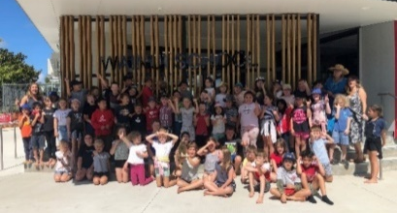
Specific Projects Sponsorship

This is a sponsorship opportunity for people/businesses who wish to contribute lump sum sponsorship towards specific Wainui School projects. This year our focus is raising funds of $100,000 The actual project/s include, finishing the Garden to Table upgrade , sponsoring the Councilor for children for a day, finishing the front entrance upgrade, musical instruments, a Junior basketball goal, scooters for the bike track, and a music lessons for more children improved with all Stakeholders. Any additional funds raised will go towards providing more educational resources. Please enquire at the office or email the Principal at gbray@wainui.school.nz to discuss Project Sponsorship opportunities. If there are any other ideas please follow the same steps as above.
Wainui School Contribution | Event Sponsor contribution
Wainui School to provide the Sponsor with recognition and opportunities to engage with Wainui School projects:  - Opportunities to connect with innovators, young entrepreneurs, fast-paced thinkers and purpose-driven young people.  - Opportunities for direct engagement with markets and customers - particularly other local businesses and future business leaders.  - Logo and/or business name displayed at Wainui School.  - Recognition and exposure on the TV Display System internal advertising.  - Logo and/or business name featured on the Wainui School donor wall.  - Digital and Social Media exposure, in a community worth belonging to.  - Regular sponsor promotion, including recognition in newsletters, featured articles and press releases.  - Exposure and recognition on collateral, invitations, advertisements and other marketing materials relating to Wainui School and at events.  - Invitation and presence at Wainui School events.  - Recognition and exposure on the Wainui School website, with logo prominently displayed and links to your business website.  - Use of Wainui School for corporate functions or community events where possible.  - Wainui School logo and collateral provided to you for use on your promotional and marketing platform. | Event Sponsor to provide the school with:  - Sponsorship lump sum payment (plus GST) on receipt of school invoice.  - Your business logo and permission to use the logo in promotional materials.  - Permission to celebrate and promote the Wainui School sponsorship partnership through articles, advertising and recognition.  - Attend Wainui School events where possible.

“We look forward to partnering with you on a Sponsorship Opportunity in the near future”

